**ROUTINE MANAGEMENT SYSTEM**

# -: Objective/Definition: -

## Class Routine System is developed using PHP, CSS, bootstrap, and JavaScript. Talking about the project, it contains an admin where he controls the whole system. The Admin plays an important role in the management of this system. In this project, the user has to perform all the main functions from the Admin side.

## Project Name : Routine Management System

## Project (TTMS)

## Language Used : PHP

## Database : MySQL

## User Interface Design : HTML, AJAX,JQUERY,JAVASCRIPT

## Web Browser : Mozilla, Google Chrome, IE8, OPERA

## Software : XAMPP / Wamp / Mamp/ Lamp (anyone)

## About System

## Talking about the features of the Class Routine System, the admin can create class and subjects for each year and for each faculty. For this, the user has to provide day, starting and ending time, unit code, venue, school, department, and year of study. The students can check their personal timetables as well as student’s detail which includes full name, school, and department, year of study and reg. no of the student. Talking about the admin panel, the admin has full access to the system. He/she can manage class records by providing names, departments by providing name and school. Here, the user can register the student’s record. Other feature includes class timetables, quiz timetables and generating results.

## Design of this project is pretty simple so that the user won’t find any difficulties while working on it. Class Routine System in PHP helps the student in managing timetables easily. To run this project you must have installed virtual server i.e XAMPP on your PC (for Windows).

## Brief overview of the technology

## HTML: HTML is used to create and save web document. E.g. Notepad/Notepad++

## CSS: (Cascading Style Sheets) Create attractive Layout

## JavaScript: it is a programming language, commonly use with web browsers.

## Back end: PHP, MySQL

## PHP: Hypertext Preprocessor (PHP) is a technology that allows software developers to create dynamically generated web pages, in HTML, XML, or other document types, as per client request.PHP is open source software.

## MySQL: MySql is a database, widely used for accessing querying, updating, and managing data in databases.

## Software Requirement (any one)

## WAMP Server

## XAMPP Server

## MAMP Server

## LAMP Server

**-: Project category: -**

Web application

**-: Software used: -**

1. **Tool:**

* Adobe Dreamweaver (8.0), VS CODE(1.68)
* XAMPP package (8.1.6)

1. **Language used:**

* PHP (5.5.12)
* My SQL (5.6.17)
* HTML (5)
* CSS(3)

1. **Platform:**

* Windows operating system.
* Google chrome, Mozilla Firefox, Opera, Internet Explorer.

**-: Hardware used:-**

|  |  |  |  |
| --- | --- | --- | --- |
| **Client Machine(minimum)** | | **Server machine(minimum)** | |
| **HDD** | 200 MB | **HDD** | 320 MB |
| **PROCESSER** | Pentium 4 or newer processor that support SSE2 | **PROCESSER** | Dual core or newer processor |

***Software Development Life Cycle (SDLC)****-*

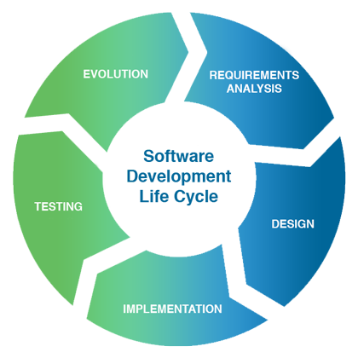

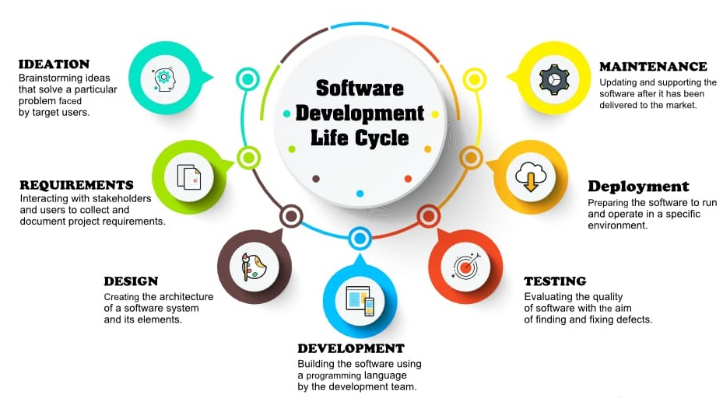

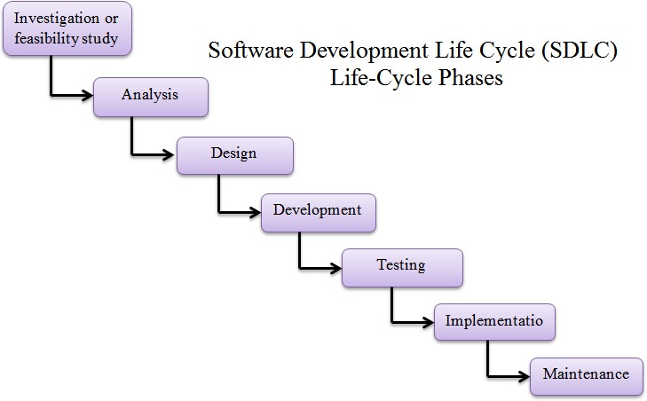

Often, a customer defines a set of general objectives for software but does not identify detailed input, processing or output requirements. In other cases, the developer may be uncured of the efficiency of an algorithm, the adaptability of an operating system, or the form that human/machine interaction should take. In these, and many other situations, a prototyping paradigm may offer the best approach. The prototyping paradigm begins with requirements gathering. Developer and customer meet and define the overall objectives for the software, identity whatever requirements are known, and outline areas where further definition is mandatory. A quick design then occurs. The quick design focuses on a representation of those aspects of the software that will be visible to the customer/user (e.g., input approaches and output formats). The quick design leads to the construction of a prototype. The prototype is evaluated by the customer/user and used to refine requirements for the software to be developed. Iteration occurs as the prototype is turned to satisfy the needs of the customer, while at the same time enabling the developer to better understand what needs to be done. Ideally, the prototype serves as a mechanism for identifying software requirements. If a working prototype is built, the developer attempts to use existing program fragments or applies tools (e.g., report generators, window managers) that enable working programs to be generated quickly.

***-: DATABASE DESIGN: -***

The database planning phase begins when a customer requests to develop a database project. It is set of tasks or activities, which decide the resources required in the database development and time limits of different activities.

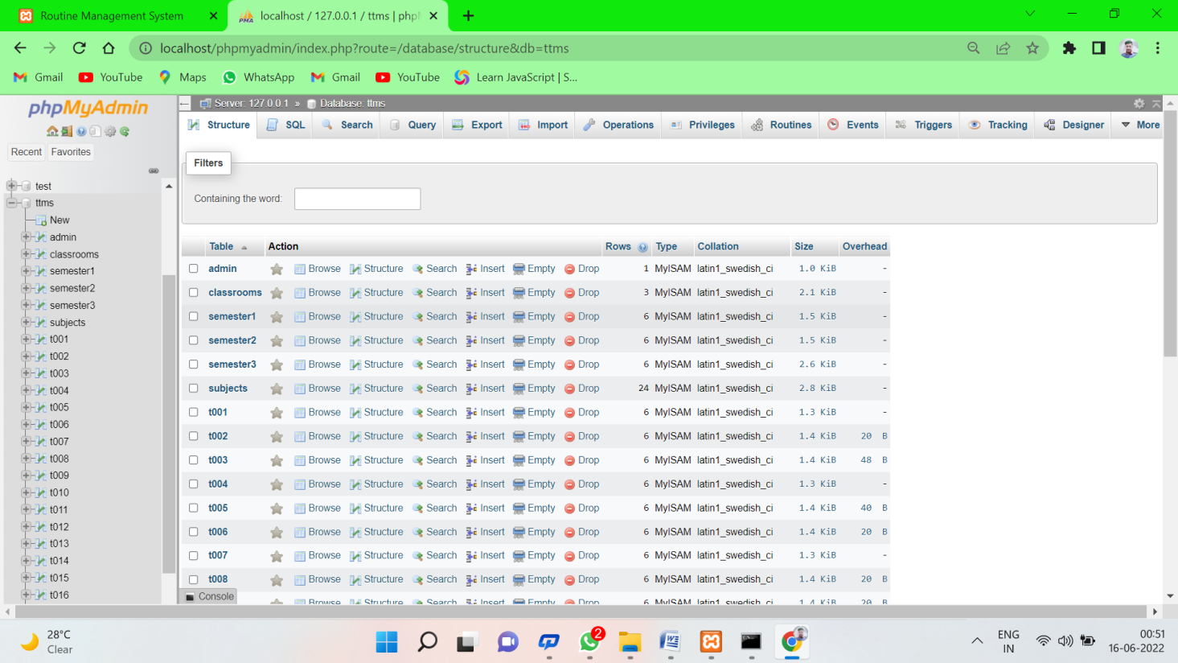

**-: SOFTWARE REQUIREMENT SPECIFICATION (SRS): -**

**COLLECTION OF REQUIREMENT**

Requirement analysis is done in order to understand the problem, which is to be solved. That is very important activity for the development of database system. The requirements and the collection analysis phase produce both data requirements and functions requirements. The data requirement is used as a source of database design. The data requirements should be specified in as detailed and complete from as possible .In parallel with specifying the data requirement; it is useful to specify the known function requirements of the application. These consist of user defined operations that will be applied to the database (retrievals and updates). The functional requirements are used as a source of application software design.

**-: THE DATA-REQUIREMENTS ARE GIVEN AS FOLLOWS:-**

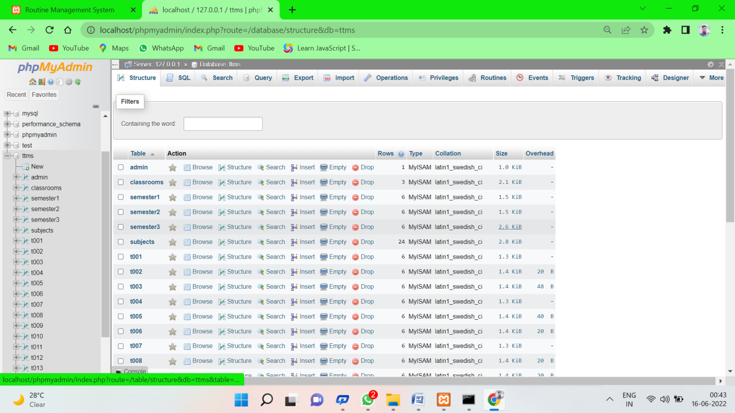

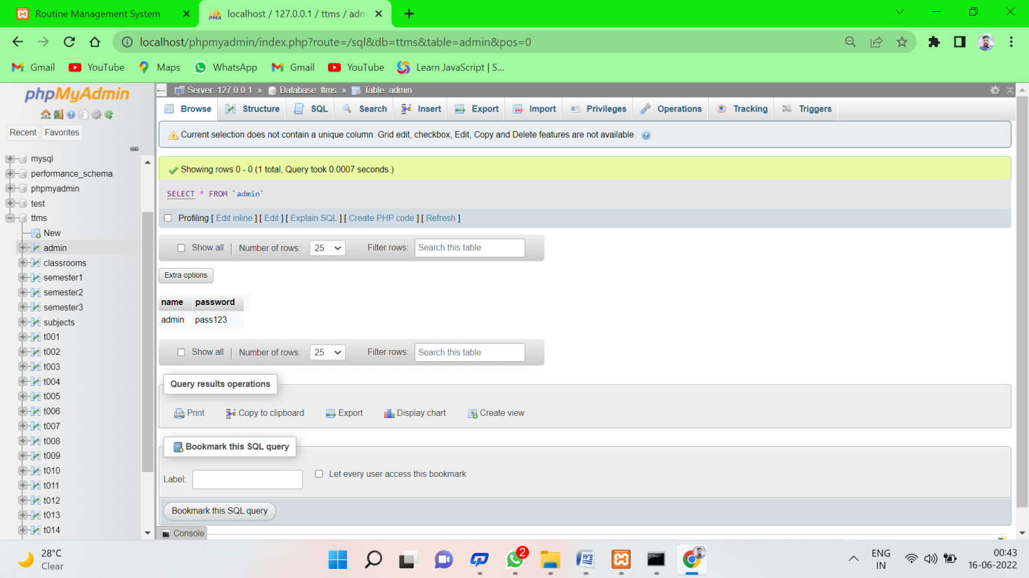

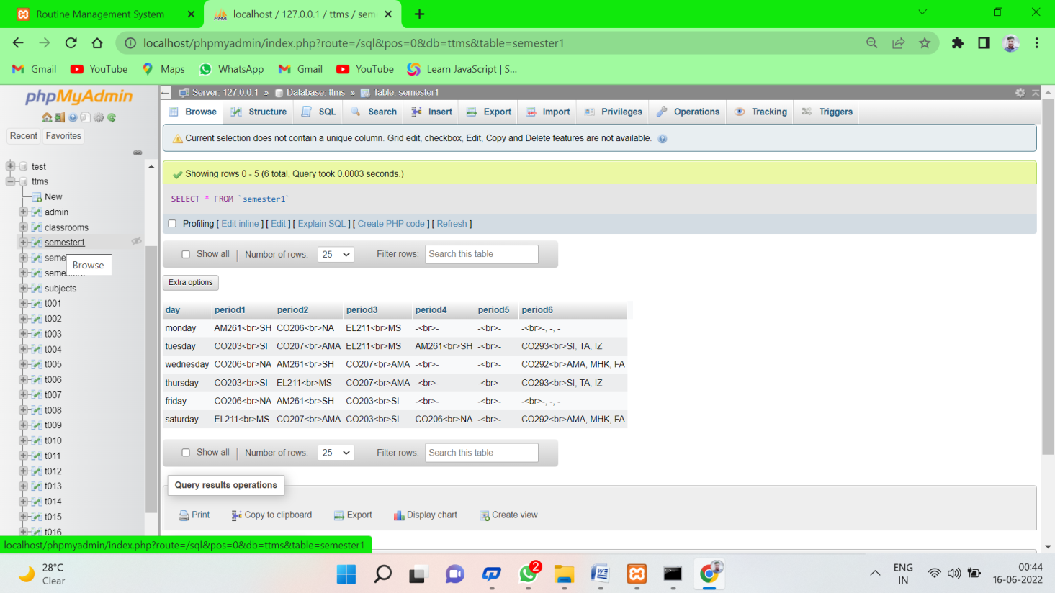

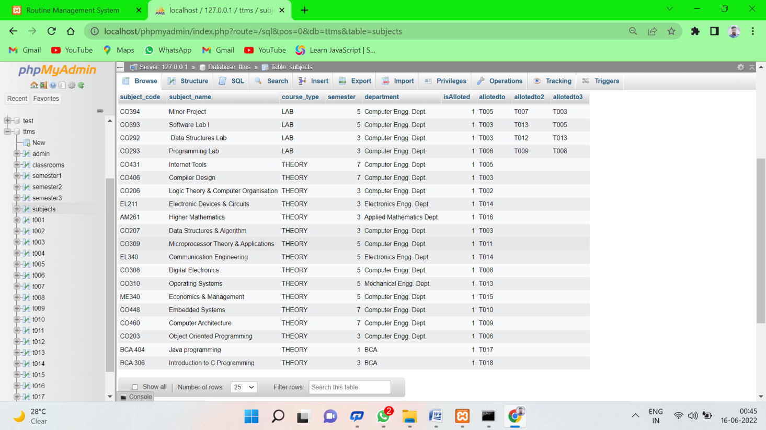

**-: ADMIN CONTROL:-**

**Admin login**

**-: Functional Requirements:-**

* + 1. The system should allow its users to see the home page.
  + 2. The system should allow its users to check routine.
  + 3. The system should allow its users to contact admin.

**-:Non-functional Requirements:-**

* + 1. The system should allow only admin can sign in to mange overall system.
  + 2. The system should be able to display the detailed admin panel information when admin log in.
  + 3. The system should allow only admin can change the welcome note.
  + 4. The system should allow only admin can check the contact details of the users.

**-: DFD AND ERD:-**

**DFD:-(level-0)**

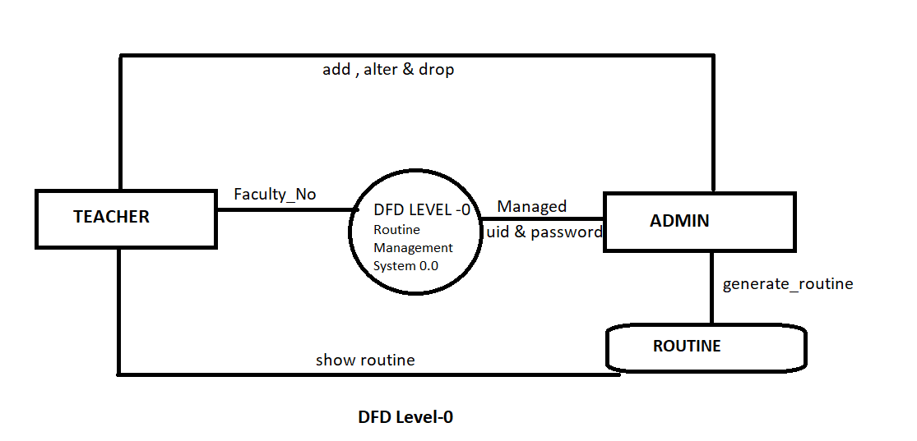

**DFD:-(level-1)**

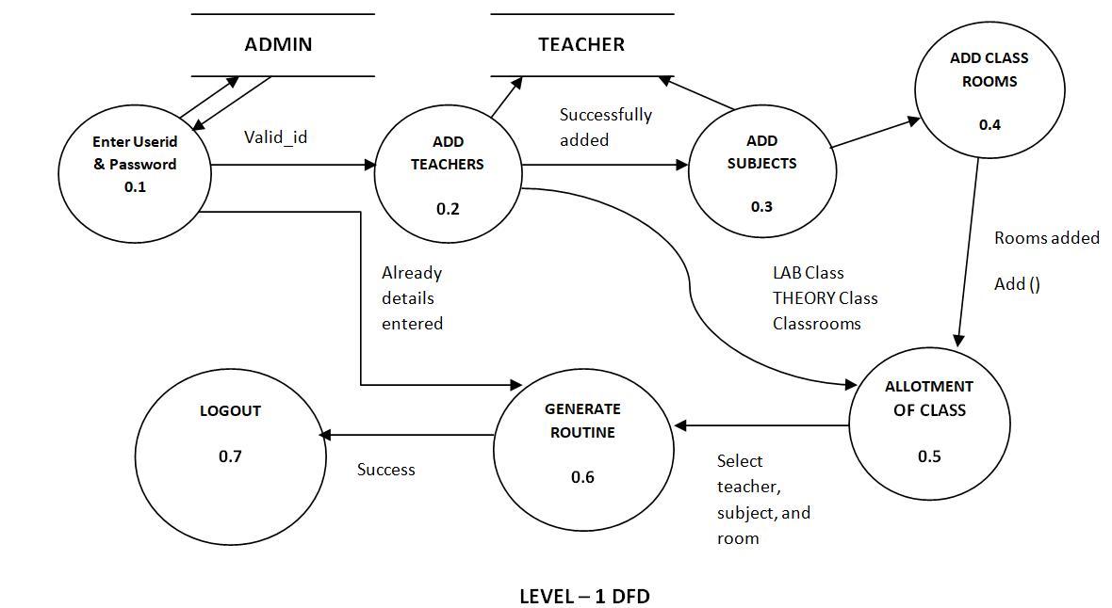

**ERD:-**

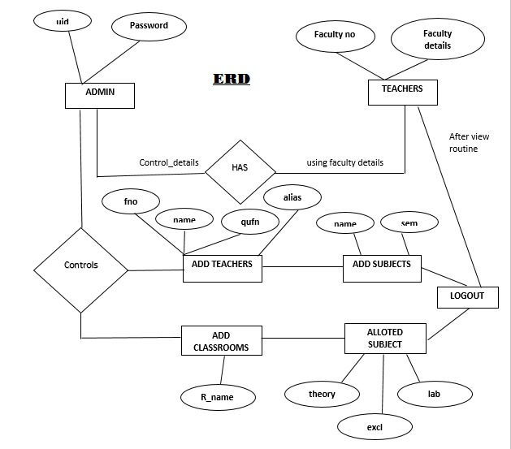

**BENEFIT**

##### **1. Availability:** The routine management system is accessible 24×7, for the teachers, students, and other staff from anywhere with the help of the internet.

##### **2. Reliability:**

Automated routine management is completely reliable, as it is designed by the inputs from school management experts.

##### **3. Optimal Scheduling:**

The intelligent design of class routine management ensures that each minute of the school is utilized for the maximum progress of students.

##### **4. Safety & Security:**

The system is highly secure as role-based permission is only provided for authorized personals.

##### **5. Flexibility:**

Class Routine Management System’s flexibility allows teachers to manage the individual students without multiplying their stress. Equally important, it keeps the teachers engaged and interested in their tasks. On the other hand, this makes them proactive and take responsibility for the individual development of students.

**-: SAMPLE OF CODDING: -**

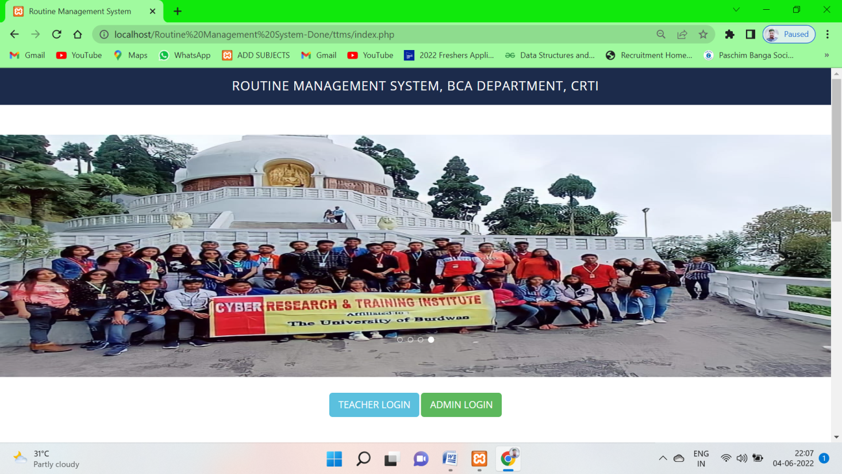

**Index.php**

<?php

if (isset($_GET['generated']) && $_GET['generated'] == "false") {

unset($_GET['generated']);

echo '<script>alert("Timetable not generated yet!!");</script>';

}

?>

<!DOCTYPE html>

<html xmlns="http://www.w3.org/1999/xhtml">

<head>

<meta charset="utf-8"/>

<meta name="viewport" content="width=device-width, initial-scale=1, maximum-scale=1"/>

<meta name="description" content=""/>

<meta name="author" content=""/>

<title>Routine Management System</title>

<!-- BOOTSTRAP CORE STYLE CSS -->

<link href="assets/css/bootstrap.css" rel="stylesheet"/>

<!-- FONT AWESOME CSS -->

<link href="assets/css/font-awesome.min.css" rel="stylesheet"/>

<!-- FLEXSLIDER CSS -->

<link href="assets/css/flexslider.css" rel="stylesheet"/>

<!-- CUSTOM STYLE CSS -->

<link href="assets/css/style.css" rel="stylesheet"/>

<!-- Google Fonts -->

<link href='http://fonts.googleapis.com/css?family=Open+Sans:400,700,300' rel='stylesheet' type='text/css'/>

</head>

<body>

<div class="navbar navbar-inverse navbar-fixed-top " id="menu">

<div class="container">

<div align="center">

<h3 align="center">ROUTINE MANAGEMENT SYSTEM, BCA DEPARTMENT, CRTI</h3>

</div>

</div>

</div>

<div id="myCarousel" class="carousel slide" data-ride="carousel">

<!-- Indicators -->

<ol class="carousel-indicators" style="margin-bottom: 160px">

<li data-target="#myCarousel" data-slide-to="0" class="active"></li>

<li data-target="#myCarousel" data-slide-to="1"></li>

<li data-target="#myCarousel" data-slide-to="2"></li>

<li data-target="#myCarousel" data-slide-to="3"></li>

</ol>

<!-- Wrapper for slides -->

<div class="carousel-inner" role="listbox">

<div class="item active">

<img src="assets/img/lab1.jpeg" alt="Chania">

</div>

<div class="item">

<img src="assets/img/lab2.jpg" alt="Chania">

</div>

<div class="item">

<img src="assets/img/lab3.jpg" alt="Flower">

</div>

<div class="item">

<img src="assets/img/lab4.jpeg" alt="Flower">

</div>

</div>

</div>

<script type="text/javascript">

function genpdf() {

var doc = new jsPDF();

doc.addHTML(document.getElementById('TT'), function () {

doc.save('demo timetable.pdf');

});

window.alert("Downloaded!");

}

</script>

<div align="center" STYLE="margin-top: 30px">

<button data-scroll-reveal="enter from the bottom after 0.2s"

id="teacherLoginBtn" class="btn btn-info btn-lg">TEACHER LOGIN

</button>

<button data-scroll-reveal="enter from the bottom after 0.2s"

id="adminLoginBtn" class="btn btn-success btn-lg">ADMIN LOGIN

</button>

</div>

<br>

<div align="center">

<form data-scroll-reveal="enter from the bottom after 0.2s" action="studentvalidation.php" method="post">

<select id="select_semester" name="select_semester" class="list-group-item">

<option selected disabled>Select Semester</option>

<option value="3"> BCA IST SEMESTER </option>

<option value="4"> BCA 2ND SEMESTER </option>

<option value="5"> BCA 3RD SEMESTER </option>

<option value="6"> BCA 4TH SEMESTER </option>

<option value="7"> BCA 5TH SEMESTER </option>

<option value="8"> BCA 6TH SEMESTER </option>

</select>

<button type="submit" class="btn btn-info btn-lg" style="margin-top: 10px">Download</button>

</form>

</div>

<!-- The Modal -->

<div id="myModal" class="modal">

<!-- Modal content -->

<div class="modal-content">

<div class="modal-header">

<span class="close">&times</span>

<h2 id="popupHead">Modal Header</h2>

</div>

<div class="modal-body" id="LoginType">

<!--Admin Login Form-->

<div style="display:none" id="adminForm">

<form action="adminFormvalidation.php" method="POST">

<div class="form-group">

<label for="adminname">Username</label>

<input type="text" class="form-control" id="adminname" name="UN" placeholder="Username ...">

</div>

<div class="form-group">

<label for="password">Password</label>

<input type="password" class="form-control" id="password" name="PASS"

placeholder="Password ...">

</div>

<div align="right">

<input type="submit" class="btn btn-default" name="LOGIN" value="LOGIN">

</div>

</form>

</div>

</div>

<!--Faculty Login Form-->

<div style="display:none" id="facultyForm">

<form action="facultyformvalidation.php" method="POST" style="overflow: hidden">

<div class="form-group">

<label for="facultyno">Faculty No.</label>

<input type="text" class="form-control" id="facultyno" name="FN" placeholder="Faculty No. ...">

</div>

<div align="right">

<button type="submit" class="btn btn-default" name="LOGIN">LOGIN</button>

</div>

</form>

</div>

</div>

</div>

<script>

// Get the modal

var modal = document.getElementById('myModal');

// Get the button that opens the modal

var teacherLoginBtn = document.getElementById("teacherLoginBtn");

var adminLoginBtn = document.getElementById("adminLoginBtn");

var heading = document.getElementById("popupHead");

var facultyForm = document.getElementById("facultyForm");

var adminForm = document.getElementById("adminForm");

// Get the <span> element that closes the modal

var span = document.getElementsByClassName("close")[0];

// When the user clicks the button, open the modal

adminLoginBtn.onclick = function () {

modal.style.display = "block";

heading.innerHTML = "Admin Login";

adminForm.style.display = "block";

facultyForm.style.display = "none";

}

teacherLoginBtn.onclick = function () {

modal.style.display = "block";

heading.innerHTML = "Faculty Login";

facultyForm.style.display = "block";

adminForm.style.display = "none";

}

// When the user clicks on <span> (x), close the modal

span.onclick = function () {

modal.style.display = "none";

adminForm.style.display = "none";

facultyForm.style.display = "none";

}

// When the user clicks anywhere outside of the modal, close it

window.onclick = function (event) {

if (event.target == modal) {

modal.style.display = "none";

}

}

</script>

<!--HOME SECTION END-->

<!--HOME SECTION TAG LINE END-->

<div id="faculty-sec">

<div class="container set-pad">

<div class="row text-center">

<div class="col-lg-8 col-lg-offset-2 col-md-8 col-sm-8 col-md-offset-2 col-sm-offset-2">

<h1 data-scroll-reveal="enter from the bottom after 0.1s" class="header-line">OUR FACULTY </h1>

</div>

</div>

<!--/.HEADER LINE END-->

<div class="row">

<div class="col-lg-4 col-md-4 col-sm-4" data-scroll-reveal="enter from the bottom after 0.4s">

<div class="faculty-div">

<img src="assets/img/faculty/indranil.jpeg" class="img-rounded"/>

<h3 align="center">Prof. INDRANIL DEBGUPTA</h3>

<hr/>

<h4 align="center">CRTI<br/>PRINCIPAL</h4>

</div>

</div>

<div class="col-lg-4 col-md-4 col-sm-4" data-scroll-reveal="enter from the bottom after 0.5s">

<div class="faculty-div">

<img src="assets/img/faculty/sugata.jpeg" class="img-rounded"/>

<h3 align="center">PROF. SUGATA GHOSH</h3>

<hr/>

<h4 align="center">CRTI<br/> HOD BCA DEPT.</h4>

</div>

</div>

<div class="col-lg-4 col-md-4 col-sm-4" data-scroll-reveal="enter from the bottom after 0.6s">

<div class="faculty-div">

<img src="assets/img/faculty/sarjita.jpeg" class="img-rounded"/>

<h3 align="center">PROF. SARJITA SOO</h3>

<hr/>

<h4 align="center">CRTI<br/>Assistant Professor</h4>

</div>

</div>

</div>

</div>

</div>

<div class="container">

<div class="row set-row-pad">

<div class="col-lg-4 col-md-4 col-sm-4 col-lg-offset-1 col-md-offset-1 col-sm-offset-1 "

data-scroll-reveal="enter from the bottom after 0.4s">

<h2><strong>Our Location </strong></h2>

<hr/>

<div>

<h4>Find Us Anywhere,

</h4>

<h4> Said Anywhere</h4>

<h4><strong>Call:</strong> 0342 256 8909 Ext 2568896 </h4>

<h4><strong>Email: </strong>info@bcrti.co.in</h4>

<h4><strong>Develop by <br> || PRAMIT CHOUDHURY || <br> || RITWIK MUKHERJEE ||</strong></h4>

</div>

</div>

<div class="col-lg-4 col-md-4 col-sm-4 col-lg-offset-1 col-md-offset-1 col-sm-offset-1"

data-scroll-reveal="enter from the bottom after 0.4s">

<h2><strong>Social Conectivity </strong></h2>

<hr/>

<div>

<a href="https://www.facebook.com/crti.burdwan"> <img src="assets/img/Social/facebook.png" alt=""/></a>

<a href="https://www.bcrti.co.in/"> <img src="assets/img/Social/website.png" alt=""/></a>

<a href="https://twitter.com/"> <img src="assets/img/Social/twitter.png" alt=""/></a>

</div>

</div>

</div>

</div>

<!-- CONTACT SECTION END-->

<div id="footer">

<!-- &copy 2014 yourdomain.com | All Rights Reserved | <a href="http://binarytheme.com" style="color: #fff" target="_blank">Design by : binarytheme.com</a>

--></div>

<!-- FOOTER SECTION END-->

<!-- Jquery Core Script -->

<script src="assets/js/jquery-1.10.2.js"></script>

<!-- Core Bootstrap Script -->

<script src="assets/js/bootstrap.js"></script>

<!-- Flexslider Scripts -->

<script src="assets/js/jquery.flexslider.js"></script>

<!-- Scrolling Reveal Script -->

<script src="assets/js/scrollReveal.js"></script>

<!-- Scroll Scripts -->

<script src="assets/js/jquery.easing.min.js"></script>

<!-- Custom Scripts -->

<script src="assets/js/custom.js"></script>

</div>

</body>

</html>

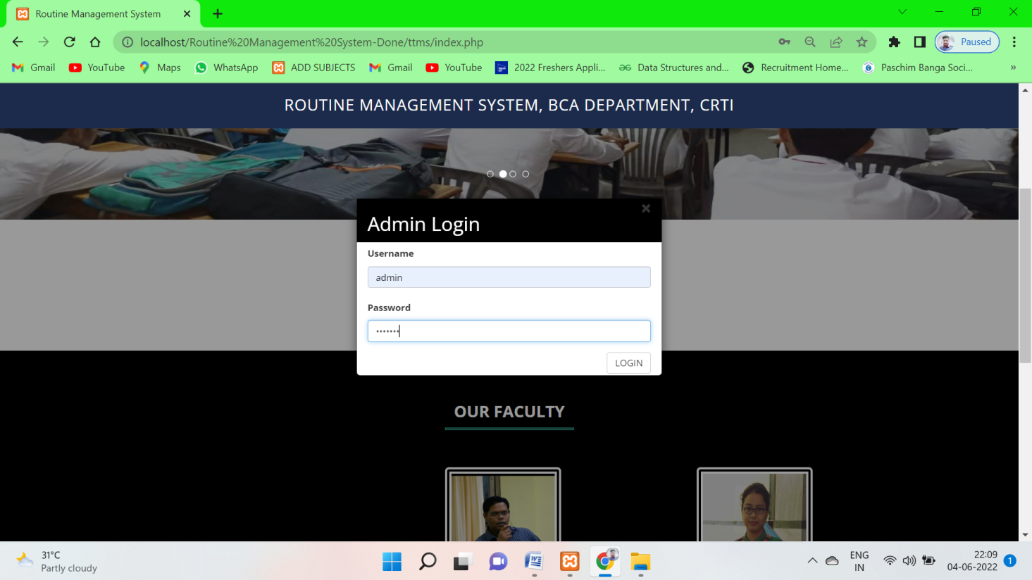

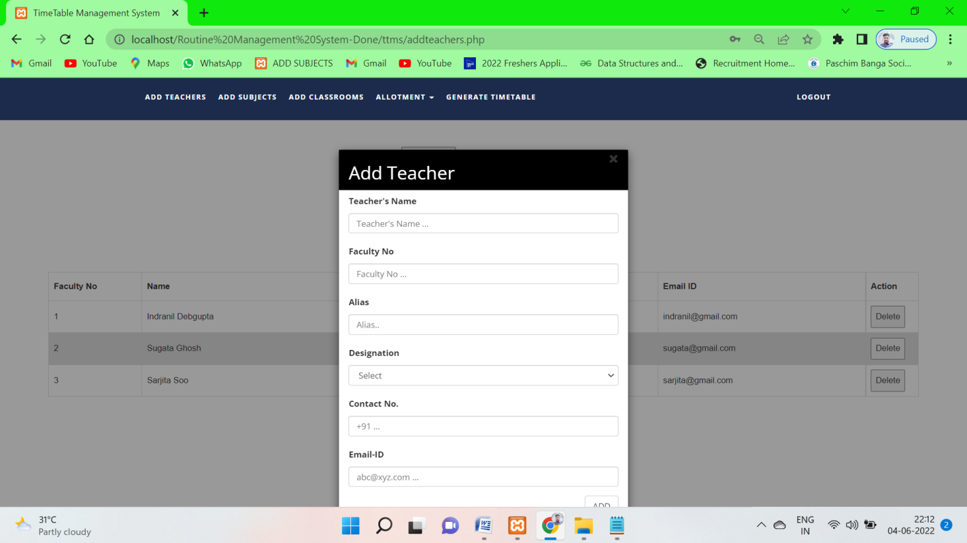

**addteachers.php**

<!DOCTYPE html>

<html xmlns="http://www.w3.org/1999/xhtml">

<head>

<meta charset="utf-8"/>

<meta name="viewport" content="width=device-width, initial-scale=1, maximum-scale=1"/>

<meta name="description" content=""/>

<meta name="author" content=""/>

<title>TimeTable Management System</title>

<!-- BOOTSTRAP CORE STYLE CSS -->

<link href="assets/css/bootstrap.css" rel="stylesheet"/>

<!-- FONT AWESOME CSS -->

<link href="assets/css/font-awesome.min.css" rel="stylesheet"/>

<!-- FLEXSLIDER CSS -->

<link href="assets/css/flexslider.css" rel="stylesheet"/>

<!-- CUSTOM STYLE CSS -->

<link href="assets/css/style.css" rel="stylesheet"/>

<!-- Google Fonts -->

<link href='http://fonts.googleapis.com/css?family=Open+Sans:400,700,300' rel='stylesheet' type='text/css'/>

</head>

<body>

<div class="navbar navbar-inverse navbar-fixed-top " id="menu">

<div class="container">

<div class="navbar-header">

<button type="button" class="navbar-toggle" data-toggle="collapse" data-target=".navbar-collapse">

<span class="icon-bar"></span>

<span class="icon-bar"></span>

<span class="icon-bar"></span>

</button>

</div>

<div class="navbar-collapse collapse move-me">

<ul class="nav navbar-nav navbar-left">

<li><a href="addteachers.php">ADD TEACHERS</a></li>

<li><a href="addsubjects.php">ADD SUBJECTS</a></li>

<li><a href="addclassrooms.php">ADD CLASSROOMS</a></li>

<li class="dropdown"><a class="dropdown-toggle" data-toggle="dropdown" aria-expanded="false">ALLOTMENT

<span class="caret"></span></a>

<ul class="dropdown-menu">

<li>

<a href=allotsubjects.php>THEORY COURSES</a>

</li>

<li>

<a href=allotpracticals.php>PRACTICAL COURSES</a>

</li>

<li>

<a href=allotclasses.php>CLASSROOMS</a>

</li>

</ul>

</li>

<li><a href="generatetimetable.php">GENERATE TIMETABLE</a></li>

</ul>

<ul class="nav navbar-nav navbar-right">

<li><a href="index.php">LOGOUT</a></li>

</ul>

</div>

</div>

</div>

<!--NAVBAR SECTION END-->

<br>

<div align="center" style="margin-top:80px">

<form name="import" method="post" enctype="multipart/form-data">

<input type="file" name="file"/>

<input type="submit" name="teacherexcel" id="teacherexcel" class="btn btn-info btn-lg" value="IMPORT EXCEL"/>

</form>

<?php

if (isset($_POST['teacherexcel'])) {

if (empty($_FILES['file']['tmp_name'])) {

echo '<script>alert("Select a file first! ");</script>';

} else {

$file = $_FILES['file']['tmp_name'];

$handle = fopen($file, 'r');

$headings = true;

while (!feof($handle)) {

$filesop = fgetcsv($handle, 1000);

$facno = $filesop[0];

$name = $filesop[1];

$alias = $filesop[2];

$designation = $filesop[3];

$contact = $filesop[4];

$email = $filesop[5];

if ($facno == "" || $facno == "Faculty No.") {

continue;

}

$q = mysqli_query(mysqli_connect("localhost", "root", "", "ttms"),

"INSERT INTO teachers VALUES ('$facno','$name','$alias','$designation','$contact','$email')");

if ($q) {

$sql = "CREATE TABLE " . $facno . " (

day VARCHAR(10) PRIMARY KEY,

period1 VARCHAR(30),

period2 VARCHAR(30),

period3 VARCHAR(30),

period4 VARCHAR(30),

period5 VARCHAR(30),

period6 VARCHAR(30)

)";

mysqli_query(mysqli_connect("localhost", "root", "", "ttms"), $sql);

$days = array('monday', 'tuesday', 'wednesday', 'thursday', 'friday', 'saturday');

for ($i = 0; $i < 6; $i++) {

$day = $days[$i];

$sql = "INSERT into " . $facno . " VALUES('$day','','','','','','')";

mysqli_query(mysqli_connect("localhost", "root", "", "ttms"), $sql);

}

}

}

}

}

?>

</div>

<div align="center" style="margin-top:20px">

<button id="teachermanual" class="btn btn-success btn-lg">ADD TEACHER</button>

</div>

<div id="myModal" class="modal">

<!-- Modal content -->

<div class="modal-content" style="margin-top: -60px">

<div class="modal-header">

<span class="close">&times</span>

<h2 id="popupHead">Add Teacher</h2>

</div>

<div class="modal-body" id="EnterTeacher">

<!--Admin Login Form-->

<div style="display:none" id="addTeacherForm">

<form action="addteacherFormValidation.php" method="POST">

<div class="form-group">

<label for="teachername">Teacher's Name</label>

<input type="text" class="form-control" id="teachername" name="TN"

placeholder="Teacher's Name ...">

</div>

<div class="form-group">

<label for="TF">Faculty No</label>

<input type="text" class="form-control" id="facultyno" name="TF" placeholder="Faculty No ...">

</div>

<div class="form-group">

<label for="TF">Alias</label>

<input type="text" class="form-control" id="alias_name" name="AL" placeholder="Alias..">

</div>

<div class="form-group">

<label for="designation">Designation</label>

<select class="form-control" id="designation" name="TD">

<option selected disabled>Select</option>

<option value="Professor">Professor</option>

<option value="Assistant Professor">Assistant Professor</option>

<option value="Associate Professor">Associate Professor</option>

<option value="Guest Faculty">Guest Faculty</option>

</select>

</div>

<div class="form-group">

<label for="teachercontactnumber">Contact No.</label>

<input type="text" class="form-control" id="teachercontactnumber" name="TP"

placeholder="+91 ...">

</div>

<div class="form-group">

<label for="teacheremailid">Email-ID</label>

<input type="text" class="form-control" id="teacheremailid" name="TE"

placeholder="abc@xyz.com ...">

</div>

<div align="right">

<input type="submit" class="btn btn-default" name="ADD" value="ADD">

</div>

</form>

</div>

</div>

<div class="modal-footer">

</div>

</div>

</div>

<script>

// Get the modal

var modal = document.getElementById('myModal');

// Get the button that opens the modal

var addteacherBtn = document.getElementById("teachermanual");

var heading = document.getElementById("popupHead");

var facultyForm = document.getElementById("addTeacherForm");

// Get the <span> element that closes the modal

var span = document.getElementsByClassName("close")[0];

// When the user clicks the button, open the modal

addteacherBtn.onclick = function () {

modal.style.display = "block";

//heading.innerHTML = "Faculty Login";

facultyForm.style.display = "block";

//adminForm.style.display = "none";

}

// When the user clicks on <span> (x), close the modal

span.onclick = function () {

modal.style.display = "none";

//adminForm.style.display = "none";

facultyForm.style.display = "none";

}

// When the user clicks anywhere outside of the modal, close it

window.onclick = function (event) {

if (event.target == modal) {

modal.style.display = "none";

}

}

</script>

<div>

<br>

<style>

table {

margin-top: 10px;

font-family: arial, sans-serif;

border-collapse: collapse;

margin-left: 30px;

width: 90%;

}

td, th {

border: 1px solid #dddddd;

text-align: left;

padding: 8px;

}

tr:nth-child(even) {

background-color: #dddddd;

}

</style>

<script>

function deleteHandlers() {

var table = document.getElementById("teacherstable");

var rows = table.getElementsByTagName("tr");

for (i = 0; i < rows.length; i++) {

var currentRow = table.rows[i];

//var b = currentRow.getElementsByTagName("td")[0];

var createDeleteHandler =

function (row) {

return function () {

var cell = row.getElementsByTagName("td")[0];

var id = cell.innerHTML;

var x;

if (confirm("Are You Sure?") == true) {

window.location.href = "deleteteacher.php?name=" + id;

}

};

};

currentRow.cells[6].onclick = createDeleteHandler(currentRow);

}

}

</script>

<table id=teacherstable style="margin-left: 80px">

<caption><strong>Teacher's Information </strong></caption>

<tr>

<th width="130">Faculty No</th>

<th width=290>Name</th>

<th width=50>Alias</th>

<th width="190">Designation</th>

<th width="190">Contact No.</th>

<th width="290">Email ID</th>

<th width="40">Action</th>

</tr>

<tbody>

<?php

include 'connection.php';

$q = mysqli_query(mysqli_connect("localhost", "root", "", "ttms"),

"SELECT * FROM teachers ORDER BY faculty_number ASC");

while ($row = mysqli_fetch_assoc($q)) {

echo "<tr><td>{$row['faculty_number']}</td>

<td>{$row['name']}</td>

<td>{$row['alias']}</td>

<td>{$row['designation']}</td>

<td>{$row['contact_number']}</td>

<td>{$row['emailid']}</td>

<td>

<button>Delete</button></td>

</tr>\n";

}

echo "<script>deleteHandlers();</script>";

?>

</tbody>

</table>

</div>

<!--HOME SECTION END-->

<!--<div id="footer">

<!-- &copy 2014 yourdomain.com | All Rights Reserved | <a href="http://binarytheme.com" style="color: #fff" target="_blank">Design by : binarytheme.com</a>

-->

<!-- FOOTER SECTION END-->

<!-- Jquery Core Script -->

<script src="assets/js/jquery-1.10.2.js"></script>

<!-- Core Bootstrap Script -->

<script src="assets/js/bootstrap.js"></script>

<!-- Flexslider Scripts -->

<script src="assets/js/jquery.flexslider.js"></script>

<!-- Scrolling Reveal Script -->

<script src="assets/js/scrollReveal.js"></script>

<!-- Scroll Scripts -->

<script src="assets/js/jquery.easing.min.js"></script>

<!-- Custom Scripts -->

<script src="assets/js/custom.js"></script>

</body>

</html>

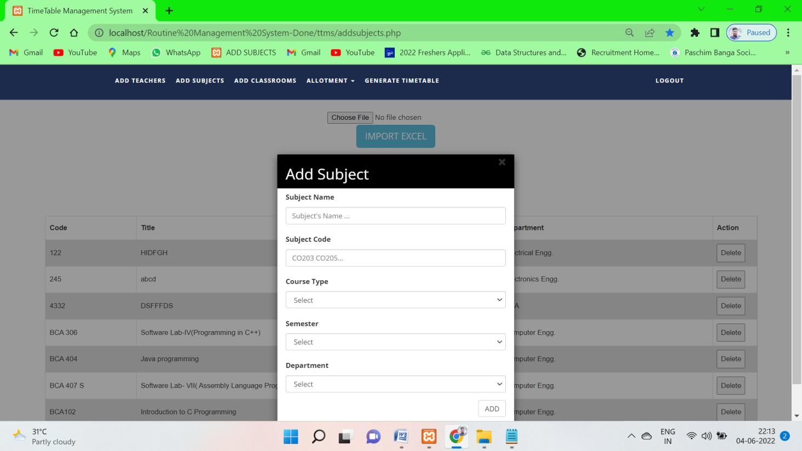

**addsubject.php**

<!DOCTYPE html>

<html xmlns="http://www.w3.org/1999/xhtml">

<head>

<meta charset="utf-8"/>

<meta name="viewport" content="width=device-width, initial-scale=1, maximum-scale=1"/>

<meta name="description" content=""/>

<meta name="author" content=""/>

<title>TimeTable Management System</title>

<!-- BOOTSTRAP CORE STYLE CSS -->

<link href="assets/css/bootstrap.css" rel="stylesheet"/>

<!-- FONT AWESOME CSS -->

<link href="assets/css/font-awesome.min.css" rel="stylesheet"/>

<!-- FLEXSLIDER CSS -->

<link href="assets/css/flexslider.css" rel="stylesheet"/>

<!-- CUSTOM STYLE CSS -->

<link href="assets/css/style.css" rel="stylesheet"/>

<!-- Google Fonts -->

<link href='http://fonts.googleapis.com/css?family=Open+Sans:400,700,300' rel='stylesheet' type='text/css'/>

</head>

<body>

<div class="navbar navbar-inverse navbar-fixed-top " id="menu">

<div class="container">

<div class="navbar-header">

<button type="button" class="navbar-toggle" data-toggle="collapse" data-target=".navbar-collapse">

<span class="icon-bar"></span>

<span class="icon-bar"></span>

<span class="icon-bar"></span>

</button>

</div>

<div class="navbar-collapse collapse move-me">

<ul class="nav navbar-nav navbar-left">

<li><a href="addteachers.php">ADD TEACHERS</a></li>

<li><a href="addsubjects.php">ADD SUBJECTS</a></li>

<li><a href="addclassrooms.php">ADD CLASSROOMS</a></li>

<li class="dropdown"><a class="dropdown-toggle" data-toggle="dropdown" aria-expanded="false">ALLOTMENT

<span class="caret"></span></a>

<ul class="dropdown-menu">

<li>

<a href=allotsubjects.php>THEORY COURSES</a>

</li>

<li>

<a href=allotpracticals.php>PRACTICAL COURSES</a>

</li>

<li>

<a href=allotclasses.php>CLASSROOMS</a>

</li>

</ul>

</li>

<li><a href="generatetimetable.php">GENERATE TIMETABLE</a></li>

</ul>

<ul class="nav navbar-nav navbar-right">

<li><a href="index.php">LOGOUT</a></li>

</ul>

</div>

</div>

</div>

<!--NAVBAR SECTION END-->

<br>

<div align="center" style="margin-top:60px">

<form name="import" method="post" enctype="multipart/form-data">

<input type="file" name="file"/>

<input type="submit" name="subjectexcel" id="subjectexcel" class="btn btn-info btn-lg" value="IMPORT EXCEL"/>

</form>

<?php

if (isset($_POST['subjectexcel'])) {

if (empty($_FILES['file']['tmp_name'])) {

echo '<script>alert("Select a file first! ");</script>';

} else {

$file = $_FILES['file']['tmp_name'];

$handle = fopen($file, 'r');

while (!feof($handle)) {

$filesop = fgetcsv($handle, 1000);

$code = $filesop[0];

$name = $filesop[1];

$type = $filesop[2];

$semester = $filesop[3];

$department = $filesop[4];

if ($code == "" || $code == "Subject Code") {

continue;

}

$q = mysqli_query(mysqli_connect("localhost", "root", "", "ttms"),

"INSERT INTO subjects VALUES ('$code','$name','$type','$semester','$department',0,'','','')");

}

}

}

?>

</div>

<div align="center" style="margin-top: 20px">

<button id="subjectmanual" class="btn btn-success btn-lg">ADD SUBJECT</button>

</div>

<div id="myModal" class="modal">

<!-- Modal content -->

<div class="modal-content">

<div class="modal-header">

<span class="close">&times</span>

<h2 id="popupHead">Add Subject</h2>

</div>

<div class="modal-body" id="EnterSubject">

<!--Admin Login Form-->

<div style="display:none" id="addSubjectForm">

<form action="addsubjectFormValidation.php" method="POST">

<div class="form-group">

<label for="subjectname">Subject Name</label>

<input type="text" class="form-control" id="subjectname" name="SN"

placeholder="Subject's Name ...">

</div>

<div class="form-group">

<label for="subjectcode">Subject Code</label>

<input type="text" class="form-control" id="subjectcode" name="SC" placeholder="CO203 CO205...">

</div>

<div class="form-group">

<label for="subjecttype">Course Type</label>

<select class="form-control" id="subjecttype" name="ST">

<option selected disabled>Select</option>

<option value="THEORY">THEORY</option>

<option value="LAB">LAB</option>

</select>

</div>

<div class="form-group">

<label for="subjectsemester">Semester</label>

<select class="form-control" id="subjectsemester" name="SS">

<option selected disabled>Select</option>

<option value="1">1</option>

<option value="2">2</option>

<option value="3">3</option>

<option value="4">4</option>

<option value="5">5</option>

<option value="6">6</option>

</select>

</div>

<div class="form-group">

<label for="subjectdepartment">Department</label>

<select class="form-control" id="subjectdepartment" name="SD">

<option selected disabled>Select</option>

<option value="BCA">BCA</option>

<option value="BBA">BBA</option>

<option value="BIO-TECH">BIO-TECH</option>

<option value="BIO-CHEM">BIO-CHEM</option>

</select>

</div>

<div align="right" class="form-group">

<input type="submit" class="btn btn-default" name="ADD" value="ADD">

</div>

</form>

</div>

</div>

<div class="modal-footer">

</div>

</div>

</div>

<script>

// Get the modal

var modal = document.getElementById('myModal');

// Get the button that opens the modal

var addsubjectBtn = document.getElementById("subjectmanual");

var heading = document.getElementById("popupHead");

var subjectForm = document.getElementById("addSubjectForm");

// Get the <span> element that closes the modal

var span = document.getElementsByClassName("close")[0];

// When the user clicks the button, open the modal

addsubjectBtn.onclick = function () {

modal.style.display = "block";

//heading.innerHTML = "Faculty Login";

subjectForm.style.display = "block";

//adminForm.style.display = "none";

}

// When the user clicks on <span> (x), close the modal

span.onclick = function () {

modal.style.display = "none";

//adminForm.style.display = "none";

subjectForm.style.display = "none";

}

// When the user clicks anywhere outside of the modal, close it

window.onclick = function (event) {

if (event.target == modal) {

modal.style.display = "none";

}

}

</script>

<div>

<br>

<style>

table {

margin-top: 10px;

font-family: arial, sans-serif;

border-collapse: collapse;

margin-left: 50px;

width: 90%;

}

td, th {

border: 1px solid #dddddd;

text-align: left;

padding: 8px;

}

tr:nth-child(even) {

background-color: #dddddd;

}

</style>

<script>

function deleteHandlers() {

var table = document.getElementById("subjectstable");

var rows = table.getElementsByTagName("tr");

for (i = 0; i < rows.length; i++) {

var currentRow = table.rows[i];

//var b = currentRow.getElementsByTagName("td")[0];

var createDeleteHandler =

function (row) {

return function () {

var cell = row.getElementsByTagName("td")[0];

var id = cell.innerHTML;

var x;

if (confirm("Are You Sure?") == true) {

window.location.href = "deletesubject.php?name=" + id;

}

};

};

currentRow.cells[5].onclick = createDeleteHandler(currentRow);

}

}

</script>

<table id=subjectstable style="margin-left: 90px">

<caption><strong> Subject's Information</strong></caption>

<tr>

<th width="150">Code</th>

<th width=300>Title</th>

<th width=150>Course Type</th>

<th width="150">Semester</th>

<th width="350">Department</th>

<th width="40">Action</th>

</tr>

<?php

include 'connection.php';

$q = mysqli_query(mysqli_connect("localhost", "root", "", "ttms"),

"SELECT * FROM subjects ORDER BY subject_code ASC ");

while ($row = mysqli_fetch_assoc($q)) {

echo "<tr><td>{$row['subject_code']}</td>

<td>{$row['subject_name']}</td>

<td>{$row['course_type']}</td>

<td>{$row['semester']}</td>

<td>{$row['department']}</td>

<td><button>Delete</button></td>

</tr>\n";

}

echo "<script>deleteHandlers();</script>";

?>

</table>

</div>

<!--HOME SECTION END-->

<!--<div id="footer">

<!-- &copy 2014 yourdomain.com | All Rights Reserved | <a href="http://binarytheme.com" style="color: #fff" target="_blank">Design by : binarytheme.com</a>

--></div>

<!-- FOOTER SECTION END-->

<!-- Jquery Core Script -->

<script src="assets/js/jquery-1.10.2.js"></script>

<!-- Core Bootstrap Script -->

<script src="assets/js/bootstrap.js"></script>

<!-- Flexslider Scripts -->

<script src="assets/js/jquery.flexslider.js"></script>

<!-- Scrolling Reveal Script -->

<script src="assets/js/scrollReveal.js"></script>

<!-- Scroll Scripts -->

<script src="assets/js/jquery.easing.min.js"></script>

<!-- Custom Scripts -->

<script src="assets/js/custom.js"></script>

</body>

</html>

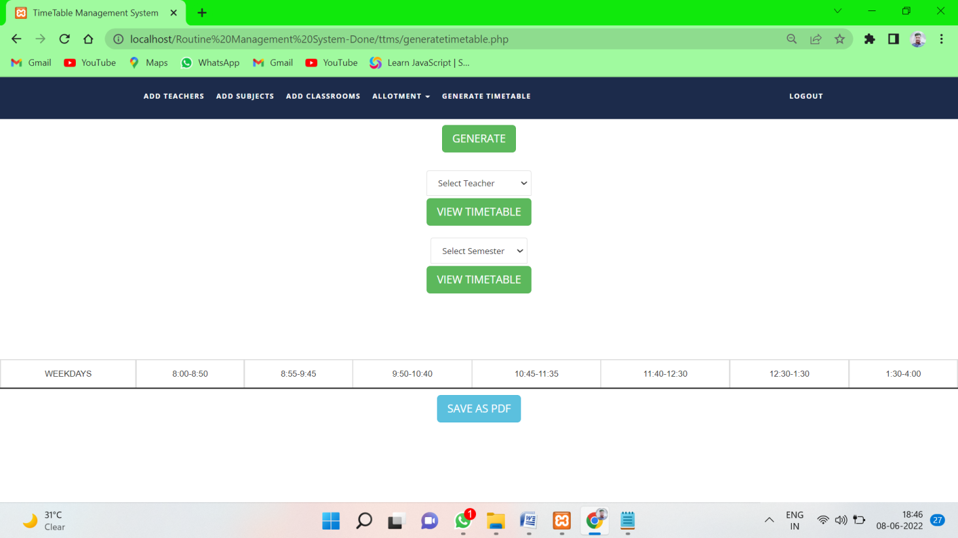

**generatetimetable.php**

<?php

// Start the session

session_start();

if (isset($_GET['success'])) {

echo "<script type='text/javascript'>alert('Time Table Generated');</script>";

}

?>

<!DOCTYPE html>

<html xmlns="http://www.w3.org/1999/xhtml">

<head>

<meta charset="utf-8"/>

<meta name="viewport" content="width=device-width, initial-scale=1, maximum-scale=1"/>

<meta name="description" content=""/>

<meta name="author" content=""/>

<title>TimeTable Management System</title>

<script type="text/javascript" src="assets/jsPDF/dist/jspdf.min.js"></script>

<script type="text/javascript" src="assets/js/html2canvas.js"></script>

<!-- BOOTSTRAP CORE STYLE CSS -->

<link href="assets/css/bootstrap.css" rel="stylesheet"/>

<!-- FONT AWESOME CSS -->

<link href="assets/css/font-awesome.min.css" rel="stylesheet"/>

<!-- FLEXSLIDER CSS -->

<link href="assets/css/flexslider.css" rel="stylesheet"/>

<!-- CUSTOM STYLE CSS -->

<link href="assets/css/style.css" rel="stylesheet"/>

<!-- Google Fonts -->

<link href='http://fonts.googleapis.com/css?family=Open+Sans:400,700,300' rel='stylesheet' type='text/css'/>

</head>

<body>

<div class="navbar navbar-inverse navbar-fixed-top " id="menu">

<div class="container">

<div class="navbar-header">

<button type="button" class="navbar-toggle" data-toggle="collapse" data-target=".navbar-collapse">

<span class="icon-bar"></span>

<span class="icon-bar"></span>

<span class="icon-bar"></span>

</button>

</div>

<div class="navbar-collapse collapse move-me">

<ul class="nav navbar-nav navbar-left">

<li><a href="addteachers.php">ADD TEACHERS</a></li>

<li><a href="addsubjects.php">ADD SUBJECTS</a></li>

<li><a href="addclassrooms.php">ADD CLASSROOMS</a></li>

<li class="dropdown"><a class="dropdown-toggle" data-toggle="dropdown" aria-expanded="false">ALLOTMENT

<span class="caret"></span></a>

<ul class="dropdown-menu">

<li>

<a href=allotsubjects.php>THEORY COURSES</a>

</li>

<li>

<a href=allotpracticals.php>PRACTICAL COURSES</a>

</li>

<li>

<a href=allotclasses.php>CLASSROOMS</a>

</li>

</ul>

</li>

<li><a href="generatetimetable.php">GENERATE TIMETABLE</a></li>

</ul>

<ul class="nav navbar-nav navbar-right">

<li><a href="index.php">LOGOUT</a></li>

</ul>

</div>

</div>

</div>

<!--NAVBAR SECTION END-->

<br>

<!--Algorithm Implementation-->

<div id="myModal" class="modal">

<!-- Modal content -->

<div class="modal-content">

<div class="modal-header">

<span class="close">&times</span>

<h2 id="popupHead">Assign Substitute</h2>

</div>

<div class="modal-body" id="AssignSubstitute">

<!--Admin Login Form-->

<div style="display:block" id="assignSubstituteForm">

<form method="post" action="assignSubstituteFormValidation.php">

<div class="form-group">

<label for="substitute">Substitute</label>

<select class="form-control" id="substitute" name="SB">

</select>

<input type="hidden" id="cell_number" class="btn btn-default" name="CN">

</div>

<div align="right" class="form-group">

<input type="submit" id="submit" class="btn btn-default" name="ADD" value="CHECK">

</div>

</form>

</div>

</div>

</div>

</div>

<script>

var assignsubstitueForm = document.getElementById("assignSubstitueForm");

// Get the <span> element that closes the modal

var modal = document.getElementById('myModal');

var span = document.getElementsByClassName("close")[0];

span.onclick = function () {

modal.style.display = "none";

assignsubstitueForm.style.display = "none";

}

// When the user clicks anywhere outside of the modal, close it

window.onclick = function (event) {

if (event.target == modal) {

modal.style.display = "none";

assignsubstitueForm.style.display = "none";

}

}

</script>

<form action="algo.php" method="post">

<div align="center" style="margin-top: 50px">

<button type="submit"

id="generatebutton" class="btn btn-success btn-lg">GENERATE

</button>

</div>

</form>

<form action="generatetimetable.php" method="post">

<div align="center" style="margin-top: 30px">

<select name="select_teacher" class="list-group-item">

<option selected disabled>Select Teacher</option>

<?php

$q = mysqli_query(mysqli_connect("localhost", "root", "", "ttms"),

"SELECT * FROM teachers ");

while ($row = mysqli_fetch_assoc($q)) {

echo " \"<option value=\"{$row['faculty_number']}\">{$row['name']}</option>\"";

}

?>

</select>

<button type="submit" id="viewteacher" class="btn btn-success btn-lg" style="margin-top: 5px">VIEW TIMETABLE

</button>

</div>

</form>

<form action="generatetimetable.php" method="post">

<div align="center" style="margin-top: 20px">

<select name="select_semester" class="list-group-item">

<option selected disabled>Select Semester</option>

<option value="1">1</option>

<option value="2">2</option>

<option value="3">3</option>

<option value="4">4</option>

<option value="5">5</option>

<option value="6">6</option>

</select>

<button type="submit" id="viewsemester" class="btn btn-success btn-lg" style="margin-top: 5px">VIEW TIMETABLE

</button>

</div>

</form>

<script>

var index = -1;

function Substitute() {

var table = document.getElementById("timetable");

var cells = table.getElementsByTagName("td");

// window.alert(cells[3].innerHTML.toString());

for (i = 0; i < cells.length; i++) {

if (i % 8 == 6 || i % 8 == 7 || parseInt(i / 8) == 0 || i % 8 == 0) {

continue;

}

var currentCell = cells[i];

//var b = currentRow.getElementsByTagName("td")[0];

var createSubstituteHandler =

function (cell, i) {

return function () {

document.getElementById('cell_number').value = i;

index = i;

var xmlhttp = new XMLHttpRequest();

xmlhttp.onreadystatechange = function () {

if (xmlhttp.readyState == 4 && xmlhttp.status == 200) {

var modal = document.getElementById('myModal');

modal.style.display = "block";

document.getElementById("substitute").innerHTML = this.responseText;

}

};

xmlhttp.open("GET", "getcellindex.php?i=" + i, false);

xmlhttp.send();

};

};

currentCell.onclick = createSubstituteHandler(currentCell, i);

}

}

</script>

<div>

<br>

<style>

table {

margin-top: 20px;

font-family: arial, sans-serif;

border-collapse: collapse;

width: 100%;

}

td, th {

border: 2px solid #dddddd;

text-align: left;

padding: 8px;

}

tr:nth-child(even) {

background-color: #ffffff;

}

tr:nth-child(odd) {

background-color: #ffffff;

}

</style>

<div id="TT" style="background-color: #FFFFFF">

<table border="2" cellspacing="3" align="center" id="timetable">

<caption><strong><br><br>

<?php

if (isset($_POST['select_semester'])) {

echo "BCA DEPARTMENT SEMESTER " . $_POST['select_semester'] . " ";

$year = (int)($_POST['select_semester'] / 2) + $_POST['select_semester'] % 2;

$r = mysqli_fetch_assoc(mysqli_query(mysqli_connect("localhost", "root", "", "ttms"), "SELECT * from classrooms

WHERE status = '$year'"));

echo " ( " . $r['name'], " ) ";

} else if (isset($_POST['select_teacher'])) {

$id = $_POST['select_teacher'];

$r = mysqli_fetch_assoc(mysqli_query(mysqli_connect("localhost", "root", "", "ttms"), "SELECT * from teachers

WHERE faculty_number = '$id'"));

echo $r['name'];

} else if (isset($_GET['display'])) {

$id = $_GET['display'];

$r = mysqli_fetch_assoc(mysqli_query(mysqli_connect("localhost", "root", "", "ttms"), "SELECT * from teachers

WHERE faculty_number = '$id'"));

echo $r['name'];

}

?>

</strong></caption>

<tr>

<td style="text-align:center">WEEKDAYS</td>

<td style="text-align:center">8:00-8:50</td>

<td style="text-align:center">8:55-9:45</td>

<td style="text-align:center">9:50-10:40</td>

<td style="text-align:center">10:45-11:35</td>

<td style="text-align:center">11:40-12:30</td>

<td style="text-align:center">12:30-1:30</td>

<td style="text-align:center">1:30-4:00</td>

</tr>

<tr>

<?php

$table = null;

if (isset($_POST['select_semester'])) {

$table = " semester" . $_POST['select_semester'] . " ";

} else if (isset($_POST['select_teacher'])) {

$table = " " . $_POST['select_teacher'] . " ";

} else if (isset($_GET['display'])) {

$table = " " . $_GET['display'] . " ";

} else

echo '</table>';

if (isset($_POST['select_semester']) || isset($_POST['select_teacher']) || isset($_GET['display'])) {

$q = mysqli_query(mysqli_connect("localhost", "root", "", "ttms"),

"SELECT * FROM" . $table);

$qq = mysqli_query(mysqli_connect("localhost", "root", "", "ttms"),

"SELECT * FROM subjects");

$days = array('MONDAY', 'TUESDAY', 'WEDNESDAY', 'THURSDAY', 'FRIDAY', 'SATURDAY');

$i = -1;

$str = "<br>";

$tid = "";

if (isset($_POST['select_semester'])) {

while ($r = mysqli_fetch_assoc($qq)) {

if ($r['isAlloted'] == 1 && $r['semester'] == $_POST['select_semester']) {

$str .= $r['subject_code'] . ": " . $r['subject_name'] . ", ";

if (isset($r['allotedto'])) {

$id = $r['allotedto'];

$qqq = mysqli_query(mysqli_connect("localhost", "root", "", "ttms"),

"SELECT * FROM teachers WHERE faculty_number = '$id'");

$rr = mysqli_fetch_assoc($qqq);

$str .= " " . $rr['alias'] . ": " . $rr['name'] . " ";

}

if ($r['course_type'] !== "LAB") {

$str .= "<br>";

continue;

} else {

$str .= ", ";

}

if (isset($r['allotedto2'])) {

$id = $r['allotedto2'];

$qqq = mysqli_query(mysqli_connect("localhost", "root", "", "ttms"),

"SELECT * FROM teachers WHERE faculty_number = '$id'");

$rr = mysqli_fetch_assoc($qqq);

$str .= " " . $rr['alias'] . ": " . $rr['name'] . ", ";

}

if (isset($r['allotedto3'])) {

$id = $r['allotedto3'];

$qqq = mysqli_query(mysqli_connect("localhost", "root", "", "ttms"),

"SELECT * FROM teachers WHERE faculty_number = '$id'");

$rr = mysqli_fetch_assoc($qqq);

$str .= " " . $rr['alias'] . ": " . $rr['name'] . "<br>";

}

}

}

} else if (isset($_POST['select_teacher']) || isset($_GET['display'])) {

if (isset($_POST['select_teacher'])) {

$tid = $_POST['select_teacher'];

} else if (isset($_GET['display'])) {

$tid = $_GET['display'];

$tid = strtoupper($tid);

}

while ($r = mysqli_fetch_assoc($qq)) {

if ($r['isAlloted'] == 1 && $r['allotedto'] == $tid) {

$str .= $r['subject_code'] . ": " . $r['subject_name'] . " <br>";

} else if ($r['isAlloted'] == 1 && isset($r['allotedto2']) && $r['allotedto2'] == $tid) {

$str .= $r['subject_code'] . ": " . $r['subject_name'] . " <br>";

} else if ($r['isAlloted'] == 1 && isset($r['allotedto3']) && $r['allotedto3'] == $tid) {

$str .= $r['subject_code'] . ": " . $r['subject_name'] . " <br>";

}

}

}

while ($row = mysqli_fetch_assoc($q)) {

$i++;

echo "

<tr><td style=\"text-align:center\">$days[$i]</td>

<td style=\"text-align:center\">{$row['period1']}</td>

<td style=\"text-align:center\">{$row['period2']}</td>

<td style=\"text-align:center\">{$row['period3']}</td>

<td style=\"text-align:center\">{$row['period4']}</td>

<td style=\"text-align:center\">{$row['period5']}</td>

<td style=\"text-align:center\">LUNCH</td>

<td style=\"text-align:center\">{$row['period6']}</td>

</tr>\n";

}

echo '</table>';

$sign = "GENERATED VIA ROUTINE MANAGEMENT SYSTEM, BCA DEPARTMENT, CRTI.";

echo "<div style='margin-left: 10px' align='center'>" . "<br>" . $str . "<br></div>" .

"<div style='margin-left: 10px' align='center'>" . "<strong>" . $sign . "<br></strong></div>";

}

if (isset($_POST['select_teacher'])) {

echo "<script>Substitute();</script>";

$_SESSION['shown_id'] = $_POST['select_teacher'];

}

if (isset($_GET['display'])) {

echo "<script>Substitute();</script>";

$_SESSION['shown_id'] = $_GET['display'];

}

?>

</div>

</div>

<script type="text/javascript">

function gendf() {

var doc = new jsPDF();

doc.addHTML(document.getElementById('TT'), function () {

doc.save('<?php

if (isset($_POST["select_semester"])) {

echo "ttms semester " . $_POST["select_semester"];

} else if (isset($_POST["select_teacher"])) {

echo "ttms " . $_POST["select_teacher"];

} else if (isset($_GET["display"])) {

echo "ttms " . $_GET["display"];

}

?>' + '.pdf');

alert("Downloaded!");

});

}

</script>

<div align="center" style="margin-top: 10px">

<button id="saveaspdf" class="btn btn-info btn-lg" onclick="gendf()">SAVE AS PDF</button>

</div>

<!--HOME SECTION END-->

<!--<div id="footer">

<!-- &copy 2014 yourdomain.com | All Rights Reserved | <a href="http://binarytheme.com" style="color: #fff" target="_blank">Design by : binarytheme.com</a>

-->

<!-- FOOTER SECTION END-->

<!-- Jquery Core Script -->

<script src="assets/js/jquery-1.10.2.js"></script>

<!-- Core Bootstrap Script -->

<script src="assets/js/bootstrap.js"></script>

<!-- Flexslider Scripts -->

<script src="assets/js/jquery.flexslider.js"></script>

<!-- Scrolling Reveal Script -->

<script src="assets/js/scrollReveal.js"></script>

<!-- Scroll Scripts -->

<script src="assets/js/jquery.easing.min.js"></script>

<!-- Custom Scripts -->

<script src="assets/js/custom.js"></script>

</body>

</html>

**-: TESTING: -**

## Characteristics of testing:

Testing begins at the module level and works outward towards the integration of the entire computer based system. Different testing techniques are appropriate at different level of time. Testing and debugging are different activities, but debugging must be accommodated in any testing strategy.

There are different model of testing. On the basis of testing methods. There are two type of testing.

**Black-box testing.**

**White-box testing.**

* **Black-Box testing:**

Black-box tests are used to demonstrate that software function are operational, that input is properly accepted and output is correctly produced, and that integrity of external information is maintained.

* **White-Box testing:**

White-box tests are used to examine the procedural details. It checks the logical paths by test case. It can also check the conditions, loops used in the software coding. It checks that loops are working correctly on defined boundary value.

**-: Future scope: -**

**The difference area where we can use this application as:**

* Any education institution makes use of it providing class schedule
* It can be used in offices and modifications can be easily done according to requirements.

1. User to user contact process will be better with online chat system.
2. Admin can directly communicate with user.
3. **Student** Can view class routine and view class schedule status

**-: Bibliography: -**

1. PHP and MYSQL Web Development by **Luke Willing & Laura Thomson**.
2. Fundamentals of Database by **Elmashri Navathe**.